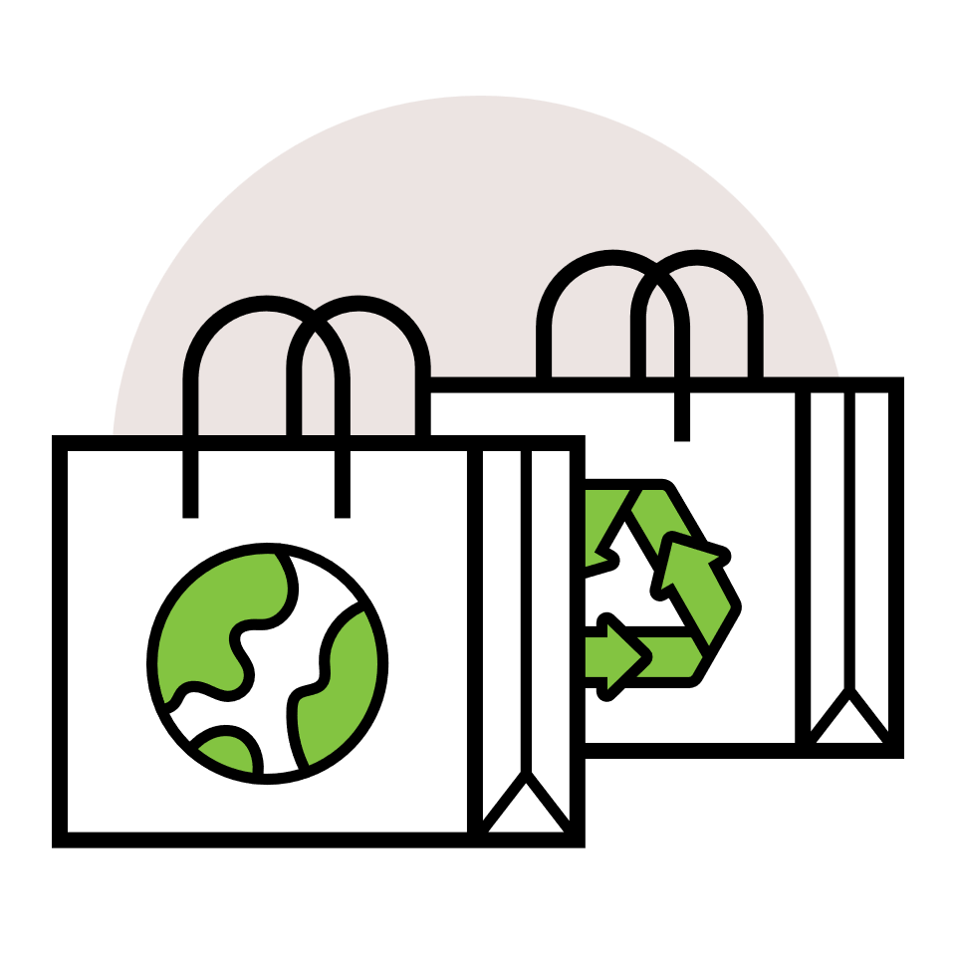
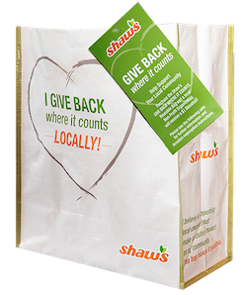

GIVE BACK WHERE IT COUNTS
rEUSABLE BAG program

Thank Your Supporters
Email & Social Post

SUBJECT: We appreciate your support!
PREVIEW TEXT: Thank you for participating in the Shaw’s GIVE BACK WHERE IT COUNTS Reusable Bag Program.

Good morning,

We are excited to announce that [name of organization] will receive $[donation amount] in donations from our partnership with the Shaw’s GIVE BACK WHERE IT COUNTS Reusable Bag Program during [month].

Thank you for your participation and support during our benefiting month of the Shaw’s GIVE BACK WHERE IT COUNTS Reusable Bag Program. Whether you bought a bag or helped spread the word, we couldn’t have done this without you!

The money we receive from Shaw’s will help us to [share what you’ll do with the donations]. Thank you again for making this a fun and successful experience for [name of the organization].

Best,
[Signature]




Share With Your Followers
Thank you for your support! We are happy to announce that we will receive $[donation amount] from our Shaw’s GIVE BACK WHERE IT COUNTS Reusable Bag Program partnership. Your support helps us continue to make a difference in community!

